|  |  |  |
| --- | --- | --- |
| **CYCLE REPORT 1** | Project Name | Project Manager |
| **Burgeen Entrepreneur and Crowd-funding System** |  |
| **Client** | **Athena Wang**  Co-founder of Burgeen.com. | |
| **Team Members** | **MingQian Li**  **YiRan Pan**  **Tyrza Adelia Winata** | |

# Red Flags from this cycle

The red flag is the first group meeting – complete

# Previous Cycle Results

Tasks that have to be completed by the end of this cycle:

* Project briefing by client – complete
* Requirements understanding and idea found – complete
* Prototype brainstorm – incomplete
* Advanced PHP technology understanding – complete

# Customer Feedback

There is still no progress on the project design, but the client provide feedback related to the first meeting and our portfolio:

* The client felt enthusiastic in describing the project as we were punctual in the first meeting and she knows that each one of us has different skill specializations.
* By seeing our portfolio, the client gave advise that we should pay more attention and do a lot of research in arranging website layout and content, because the website will lead the target audiences to get what they needed.
* The client asks us to think of new ideas to be implemented which may be better than her ideas.

# Cycle Plan (Use 2 level WBS)

1. **Project Management**

*Responsible: Charles, Li MingQian*

* 1. Project Plan
* Divide projects into phases
* Defines & refines objectives and plans
* Set the goal of overall project and for each milestone
* Integrates people & other resources to carry out the project plan
  1. Project Schedule
* Set the schedule and due dates of every project phases
  1. Requirements document
* Negotiates client requirements
* List clear statements description from client as to what they wanted
  1. Project Prototype
* Make a global prototype in accordance with the prototype brainstorm result
  1. Weekly client’s feedback
* Record every feedback given from the client
  1. Meeting agendas and duration
* Record an activity documentation for every meeting with client and its duration
* Meet with the supervisor regularly

1. **Technical Design**

*Responsible: Vizor, Pan YiRen*

* 1. Design for CMS
  2. Design for databases

1. **Implementation**

*Responsible: Tyrza Adelia Winata*

* 1. Design interfaces
* Designing the layout of each page
* Choosing and implementing suitable design elements
  1. Design for screen
* Adjust the layout for some different platform
  1. Testing
* Page test checklist
* System test checklist
* User test checklist

**Top Ten Requirements (Features)**

1. Content Management System (CMS) understanding and choosing

2. Database system understanding and choosing

3. Server operating system confirmation and configuration

4. Business model and strategy definition and differentiation

5. Analyze the target audience

6. Analyze the competitors' website

7. Formulate a feasible and aesthetic design concept

8. Collect the demand documents of customers

9. Present details of design to customers

10. Run-in period of new team members

# Supporting Documents:

Gantt chart

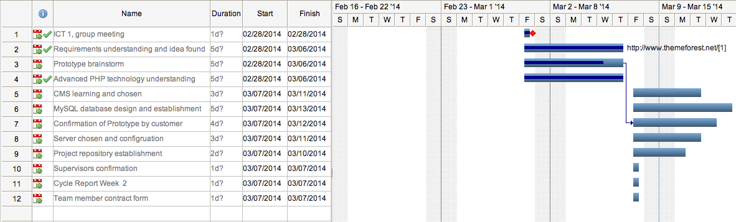

Sketch

